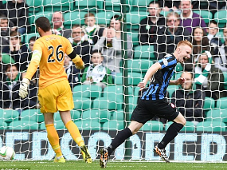 

**Hamilton Academical FC**

**Elite Junior Academy**

**Micro Sessions 2015/16**

**KEY POINTS**

**ALL MICROS SHOULD FOLLOW THE SAME INSTRUCTIONS:**

1. **4 MINS MAX PER BOX 1 MIN REST**
2. **ONE BOX SHOULD BE UNDER NO PRESSURE**
3. **AT LEAST ONE BOX SHOULD BE LIMITED PRESSURE**
4. **AT LEAST ONE BOX SHOULD BE FULL PRESSURE**
5. **PLAYERS SHOULD WORK AT HIGH TEMPO**

**1V1 SIDE BY SIDE SESSIONS**

**#1 INSIDE/OUTSIDE CUTS**

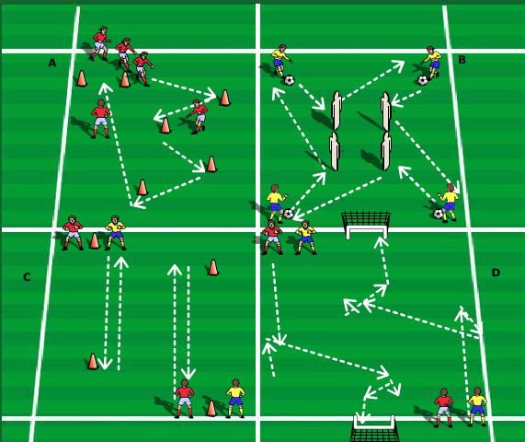

***Players perform inside and outside cuts by faking to strike ball but cuts it behind him using inside or outside of foot.***

**A – Player drives to cone and performs cut then drives to the next cone**

**B – All 4 players drive at same time to middle perform cut and drive to the left challenge players 1st one to complete the 4 corners.**

**C- Player drives to cone tracked by defending player performs cut and drives away. Players then swap over.**

**D – Player drives halfway performs cut drives inside pitch tracked by player performs cut again and shoots. Apply full Pressure players then swap.**

**#2 CRYUFF TURN AND SPIN**

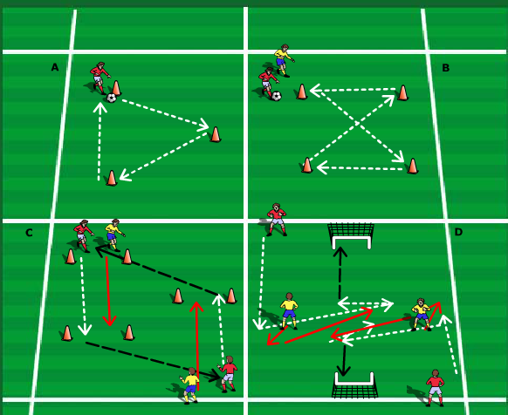

***Players beat opponent by faking to strike hooking the ball behind standing leg pivot and take ball away with outside of opposite foot.***

**A – Player drives to cone and performs turn and spin**

**B – player drives to cone tracked by defending player drive diagonal then preforms turn and spin drives to cone and performs again.**

**C – Player drives to cones performs spin and turn and switches play for team mate to repeat this**

**D – player drives down the pitch to meet defending player peforms spin and turn drives inside pitch repeats and has strike at goal**

**#3 STOP TURN AND FAKE SOLE STOP**

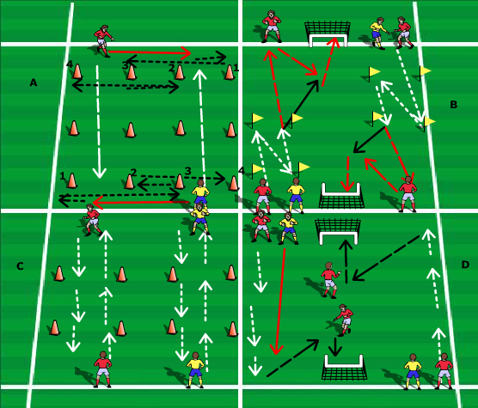

***Player beats opponent with stop turn by stopping ball with sole off foot turning and driving in opposite direction***

***Player beats opponent with fake sole stop by slowing down faking to stop ball with sole and using laces to drive away at pace.***

**A – Players pass ball down channel then go and meet pass before driving to cone 1 performing stop turn to 3 then to 2 then 4.**

**B – player drives to cone performs stop turn drives diagonal and repeats before passing to end man for bounce pass and strike at goal**

**C – Both players drive to middle perform fake sole stop before driving to end turning and repeating.**

**D – player drives half way tracked by defender performs fake sole stop repeats again to by ½ yard before crossing for striker to fininsh.**

**1V1 DIAGONAL ATTACKING MICROS**

**#1 TWIST OFF**

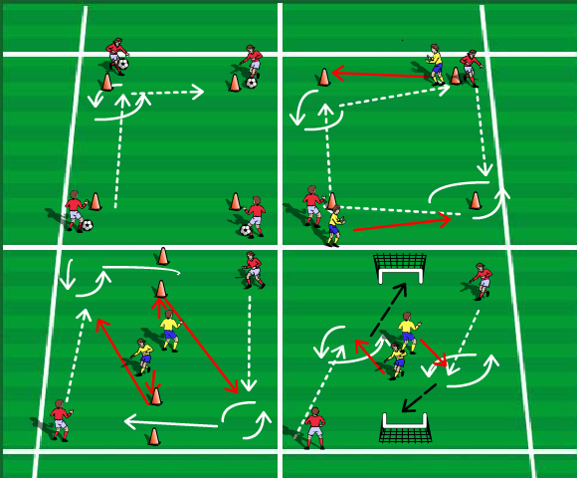

***Player beats opponent by performing inside cut to shield ball before quickly cutting again and turning into space***

**A – 4 players drive to cones to their left perform twist off and drive to next cone.**

**B – Players drive to cones opposite them being met side on from defender perform twist off and drive to cone to their right.**

**C- player drives to opposite end defending player sprints to cone and chases player who then performs twist off to get through the gates**

**D- Player drives inside game met by defender performs twist off and strike at goal.**

**#2 DRAG BACK**

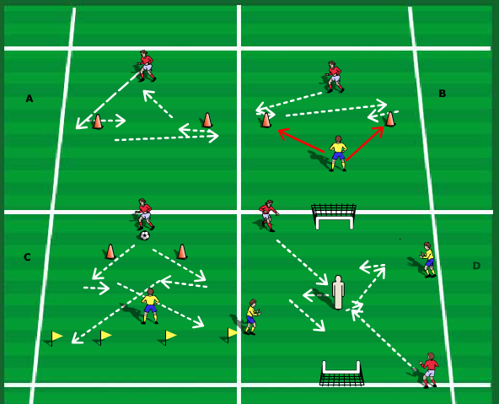

***Player beats opponent by faking to strike dragging the ball back with sole of foot and pushing off with inside or outside of drag back foot***

**A – player drives to cone to the right performs drag back drives to cone to left performs drag back and drives back to start.**

**B – same set up as box A but player is tracked by defending player with limited pressure.**

**C – player drives left or right performs drag back to drive through one of the end gates if DF wins ball they drive through top gate**

**D- Player drives to middle cone performs drag back before entering into 1v1 towards goal with DF from side.**

**#3 THE RONALDO CHOP**

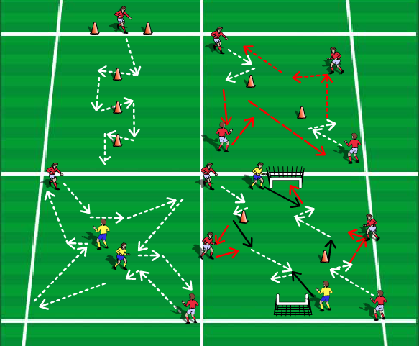

***Player beats opponent by rolling the ball behind the heel of standing foot and chopping ball infront of standing foot to change direction at pace.***

1. **Player drives to cone performs chop to the right drives to next cone and chops to the left and again with right at next cone.**
2. **Player drives to cone performs chop and plays ball to end man taking a 1-2 before driving diagonally turning and repeating.**
3. **Player drives to defender performs left or right chop to drive to corner and repeats.**
4. **Player drives to cone performs chop plays 1-2 before driving to goal met by df at angle to try and get shot at goal.**

**1V1 FACE TO FACE SITUATIONS**

**SCICCORS, STEPOVERS, SIDE STEP AND INSIDE/OUTSIDE TAKE**

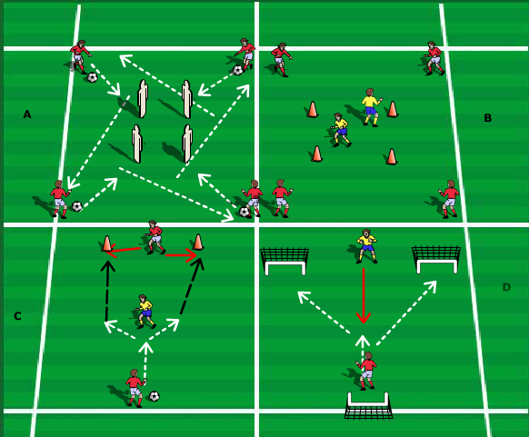

***Player beats opponent by scissor move by stepping around the ball with outside of one foot and taking away with outside of the other.***

***Player beats opponent by faking to kick ball stepping over and taking the ball away with outside of same foot.***

***Player beats opponent by driving at player fakes to pass with outside of foot but steps behind ball and takes away with outside of opposite foot.***

***Player beats opponent by taking the ball to side with outside before quickly changing direction with inside of foot or vice versa.***

**A – All players drive into middle perform one of the skills and drive away to next cone then repeat.**

**B – players drive into middle and perform skill to drive to opposite corner DF player can pressure anyone of the 4 players.**

**C – Player drives at middle player perform skill to beat opponent to play pass to end player.**

**D – DF player passes ball then 1v1 attacking player performs skill to score into either goal**

**BACK TO GOAL 1V1 SITUATIONS**

**#1 SOLE DRAG AND TURN,#2 SPIN AND DRIVE**

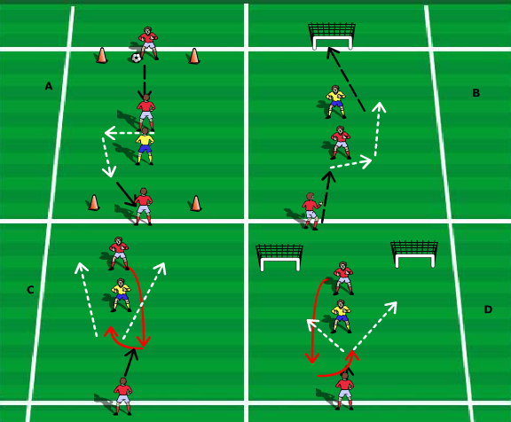

***Player beats opponent by receiving back to goal turning side on and dragging the ball away with closest foot to defender before driving away.***

***Player beats opponent by getting infront of defender receiving the ball with the inside of the foot and spins to face opponent before attacking***

**A – Ball passed into player defender presses player performs sole drag and plays end man**

**B – Same as box as this time player can go either way looking to score.**

**C – Player starts in behind DF comes in front as ball is played receives spins and goes either way.**

**D – same as box C but can go either way towards either goal.**

**#3&4 REVERSE TWIST OFF AND REVERSE STEPOVERS**

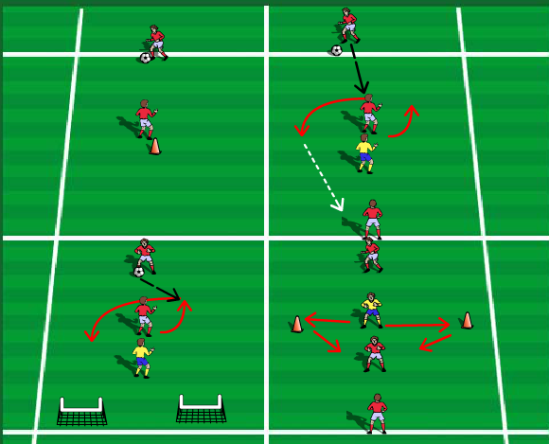

***Player beats opponent by cutting with outside of foot before quickly cutting with outside again to spin and drive space.***

***Player beats opponent by receiving ball faking to go one way stepping over ball and turning away with outside of same foot***

**A – Player passes ball player receives and performs one of the skills**

**B – Same as box A this time DF puts pressure on forcing player to scan what way to go before playing end man**

**C – Same as box B this time player looking to score in either goal**

**D – DF player moves to either side cone as ball is passed forcing AT player to check before performing skill and playing end man**

